WATER RAFTING SITE PLAN

PURPOSE

GOALS

TARGET AUDIENCE

SCENARIOS

**LOGO**

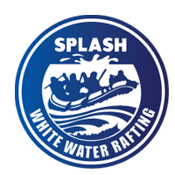

COLOR PALETTE

* primary-color : #8EF9F3
* secondary-color: #593C8F
* ascent1-color: #171738
* ascent2-color:# FFD9CE

<https://coolors.co/904c77-ffee88-00cc99-03012c-002a22>

**Typography**

Heading-font: ubuntu

Text-font: quicksand